UML Diagrams

- Class Diagram
- Use Case Diagram
- Sequence Diagrams
    - JobProvider Login Sequence Diagram
    - JobSeaker Registration Sequence Diagram
    - JobSeaker Login Sequence Diagram
    - JobSeaker Online Test Sequence Diagram
- Collaboration Diagram
    - JobProvider Login Collaboration Diagram
    - JobSeaker Registration Collaboration Diagram
    - JobSeaker Login Collaboration Diagram
    - JobSeaker Online Test Collaboration Diagram
- Deployment Diagram

Class Diagram

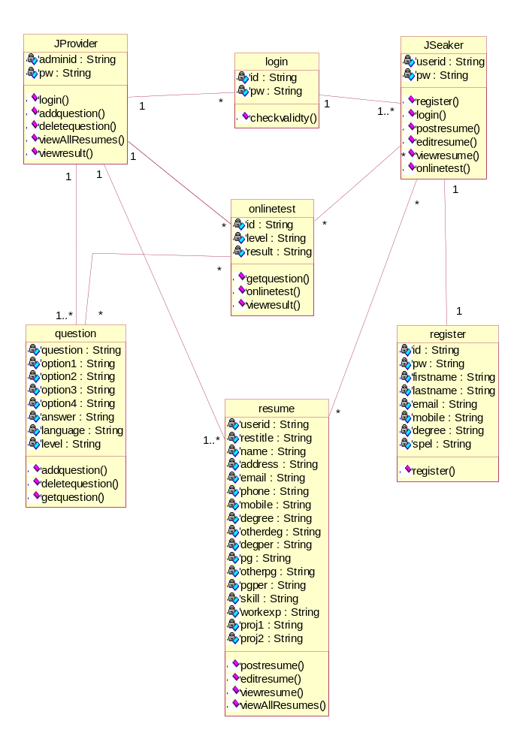
Use Case Diagram
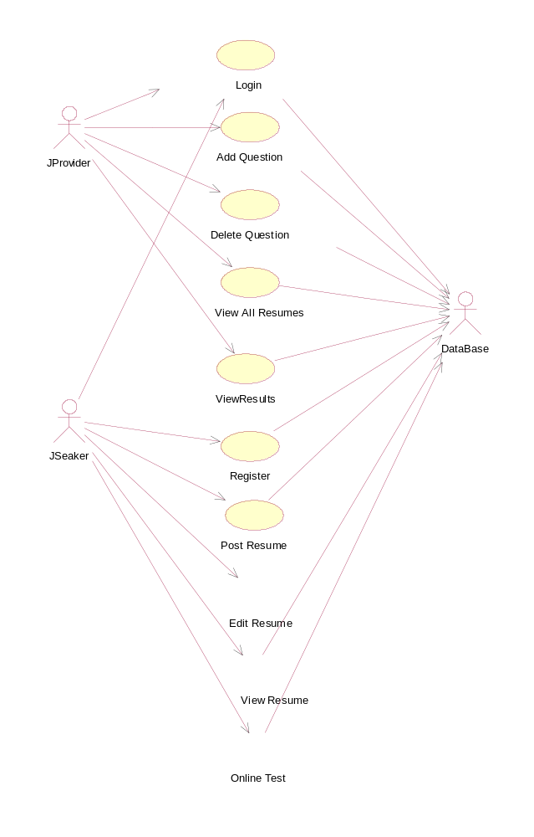

Sequence Diagrams

JobProvider Login Sequence Diagram

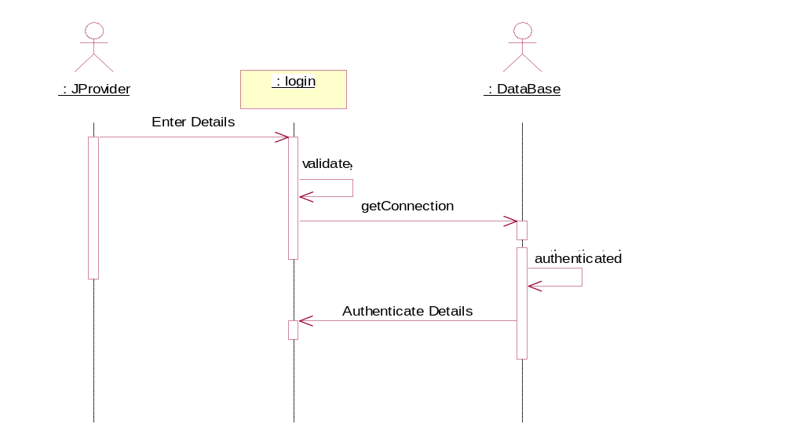

JobSeaker Registration Sequence Diagram

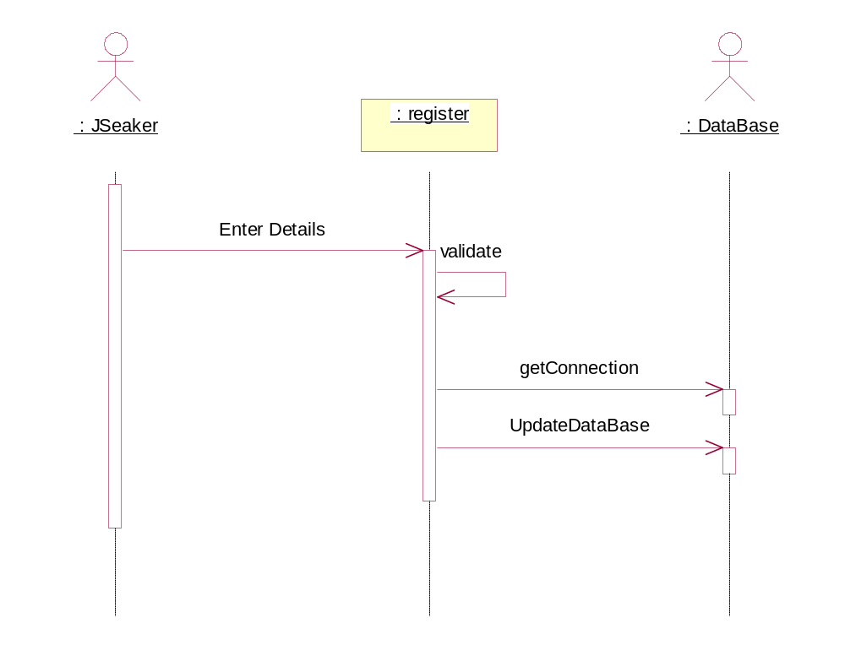

JobSeaker Login Sequence Diagram
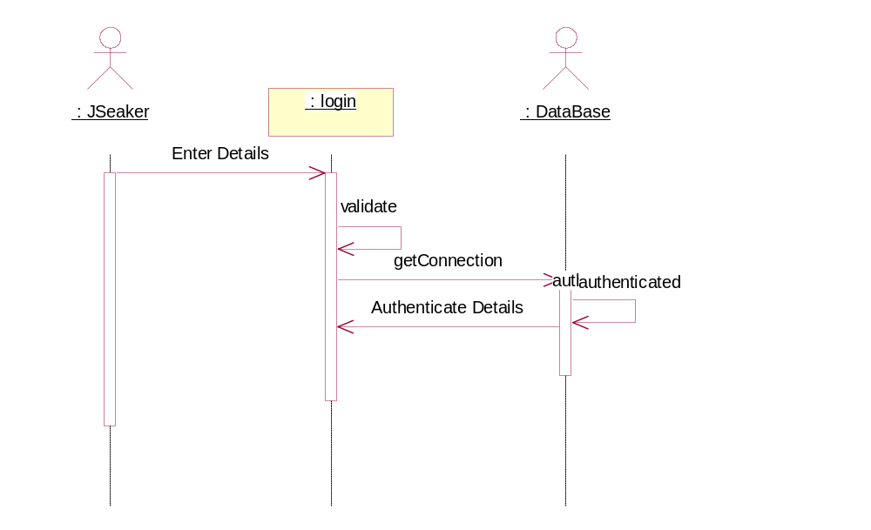

JobSeaker Online Test Sequence Diagram
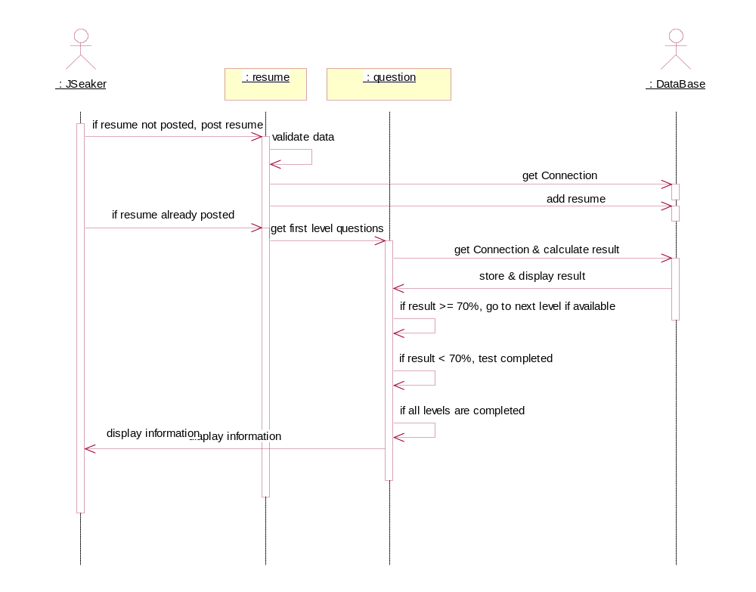

Collaboration Diagram
JobProvider Login Collaboration Diagram
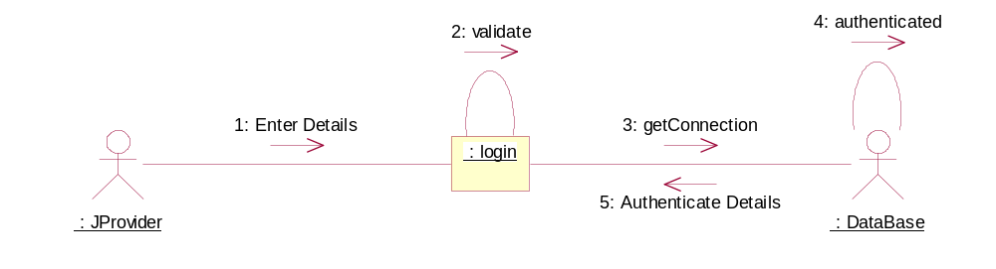

JobSeaker Registration Collaboration Diagram

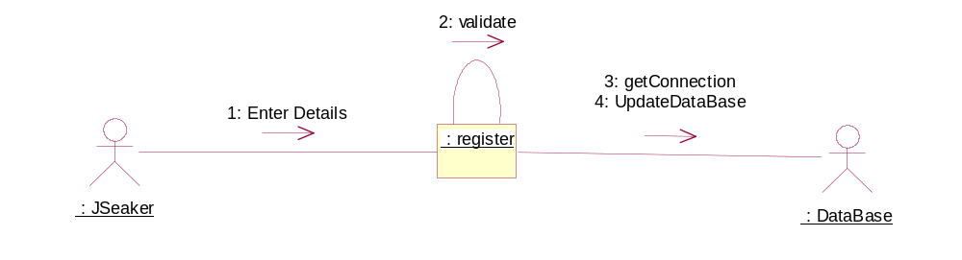

JobSeaker Login Collaboration Diagram

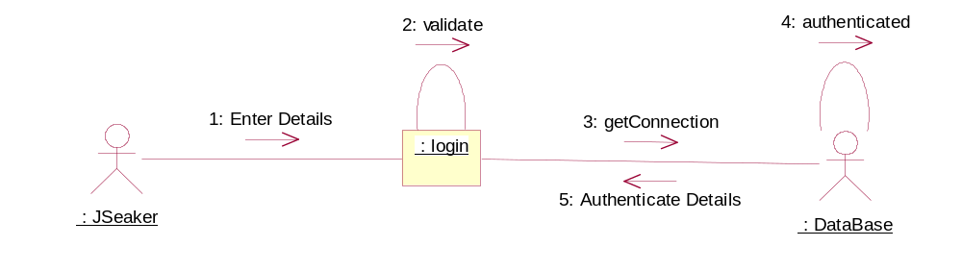

JobSeaker Online Test Collaboration Diagram

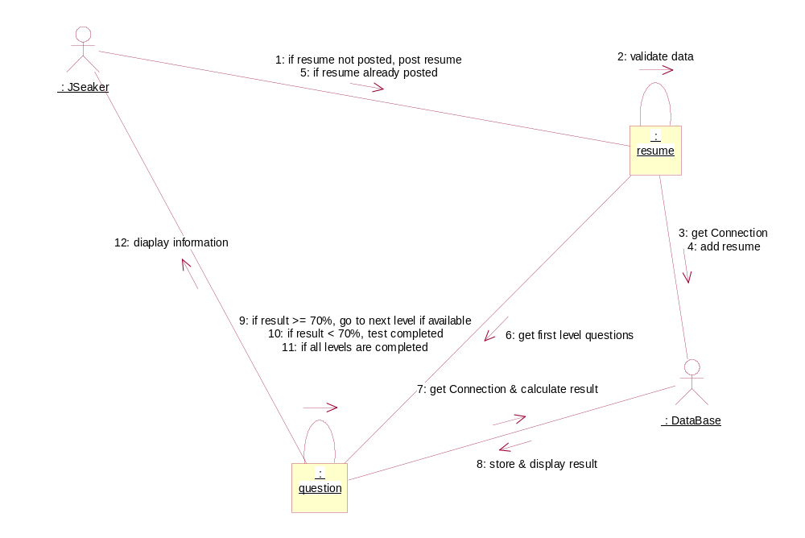

Deployment Diagram
